
QUALITY ALERT

Customer: United Date: December 11, 2023
Die: 15141 Colour: ALL
Type of Complaint: United REJECTED

Q.A # Q.I.R # CUSTOMER NCR #

Description: United REJECTED due to weatherstrips are not fully inserted, making it easy to pull out.
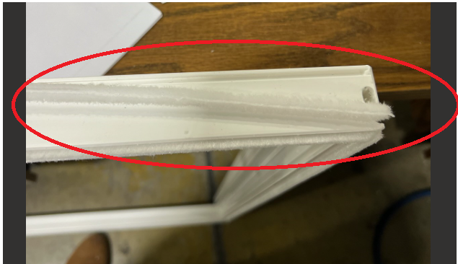
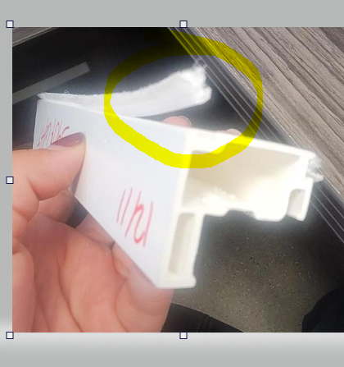

PLEASE MAKE SURE WEATHERSTRIPS ARE INSTALLED FIRM & CORRECTLY
BY SIGNING BELOW, YOU ACKNOWLEDGE THE PROBLEM ABOVE AND AGREE TO MONITOR THIS ISSUE IN FUTURE PRODUCTION RUNS.
DAY SHIFT |  | AFTERNOON SHIFT |  | NIGHT SHIFT
NAME | SIGNATURE | NAME | SIGNATURE | NAME | SIGNATURE

